**The Lobuzz:**

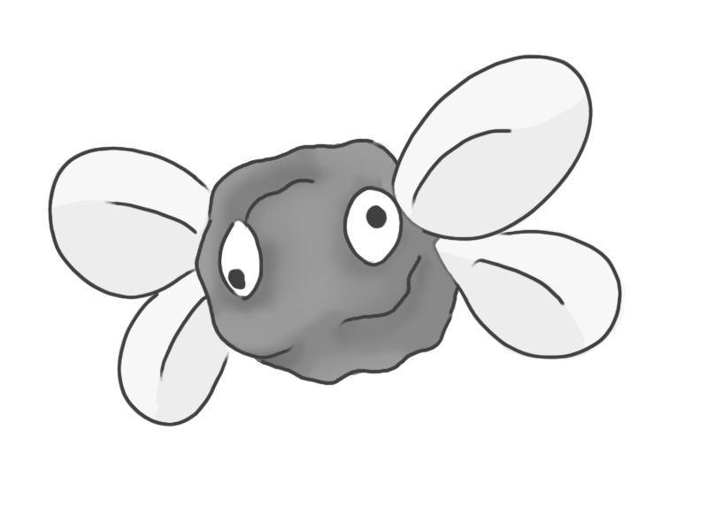

Figure 1 - Enemy: Lobuzz

**Brief Synopsis**

The Lobuzz is an enemy consisting of a ball of plasticine with googly eyes and paper wings attached. They could also have string holding them up as if attached to something far above the game’s play area, exaggerating the concept of the game being within a child’s imagination. These enemies are exceptionally weak and would, in most cases, die in one hit. The player could use these enemies to tether to when using the grapple-shot, allowing them to reach higher places. On death, this enemy will lose its flight and plummet towards the floor.

**Variants**

To differentiate between variants of the Lobuzz, the colour of the plasticine at the core of the enemy will differ:

**Yellow:**

* The enemy does not move and hovers in place.

**Blue:**

* This enemy moves along a predefined patrol route.

**Green:**

* When in range, the enemy moves towards the player to deal contact damage.

**Red:**

* When in range, the enemy moves towards the player and explodes on contact.

**AI**

The pathfinding of this enemy will require the use of an algorithm such as A*. This will only be used on variants **Red** and **Green**. **Blue** will follow a predetermined path and **Yellow** will not use any form of AI.

**Animations**

The Lobuzz will have an exceptionally simple animation, as only its wings will move. There is potential to have the googly eyes track the player as they move.

**Idle:**

* The enemy’s body will not change shape- its wings will just move up and down.

**Death:**

* It will fall out the air.

**Average Size**

